SIS Chatbot: A Bilingual AI Assistant for Sub Inspector Surveyor Officers
National Informatics Centre (NIC) Internship Project Report · Oct 15, 2026 · @MAYUR KAARTHIC S V

ABSTRACT
The Sub Inspector Surveyor (SIS) Chatbot is a bilingual (Tamil / English / Tanglish) conversational assistant built for Sub Inspector Surveyor officers of the Tamil Nadu Survey Department. SIS officers administer land-mutation applications under the TAMILNILAM Urban service catalogue — Involving Sub-Division (ISD, service code 0154) and Not-Involving Sub-Division (NISD, service code 0153) patta transfers chief among them, alongside roughly twenty-seven other service codes such as Modification, Addition, Deletion, ULC Subdivision, F-Line Demarcation and TSLR Sketch requests — and today do so largely through manual file tracking and ad-hoc register lookups across disconnected spreadsheets. This project builds a FastAPI + PostgreSQL + pgvector backend and a vanilla HTML/CSS/JS chat frontend that lets an officer ask natural-language questions — "show my pending applications", "எத்தனை CSC விண்ணப்பங்கள் நிலுவையில் உள்ளன" — and receive answers that are always derived deterministically from the department's own register, never invented by the language model. A rule-based router resolving roughly sixty distinct intents handles the deterministic majority of queries — status lookups, listings, comparisons, field-visit plans, document checks — through token-boundary and edit-distance matching tolerant of typos in three scripts. An LLM tool-calling agent, backed by a QLoRA fine-tune of a Tamil-instruction Llama 3.1 8B model served through Ollama, answers the residual free-form questions using the same fourteen authorized, jurisdiction-scoped read-only tools the deterministic path uses. The system treats every TAMILNILAM service code equally rather than special-casing ISD/NISD, enforces read-only access to departmental data at the ORM layer through a SQLAlchemy event-listener guard, and grounds every uploaded-document answer in cited page/row evidence rather than free recall. Over 60 regression test scripts covering intent routing, database invariants, bilingual phrasing and agent-tool authorization back the implementation.
Keywords: Conversational AI, Retrieval-Augmented Generation, LoRA fine-tuning, intent classification, multilingual NLP, land records, e-governance, PostgreSQL, pgvector.

TABLE OF CONTENTS
Chapter | Title
 | Abstract
 | List of Tables
 | List of Figures
 | List of Abbreviations
1 | Introduction
2 | Review of Literature
3 | System Analysis
4 | System Design
5 | System Specification
6 | Module Descriptions
7 | Software Description
8 | System Testing
9 | Source Code
10 | Result Analysis
11 | Conclusion
12 | References

LIST OF TABLES
1.1 | TAMILNILAM urban service code catalogue
No. | Title
2.1 | Summary of reviewed literature
3.1 | Existing system vs. proposed system
5.1 | Hardware requirements
5.2 | Software requirements
8.1 | Representative test cases
6.1 | Feature catalogue

LIST OF FIGURES
No. | Title
4.1 | Block diagram — end-to-end request flow
4.2 | Layered architecture diagram
4.3 | Level-1 data flow diagram
4.4 | Use case diagram
4.5 | Activity diagram — one chat turn
10.1 | Deterministic query result (service-code count)
10.2 | Bilingual (Tamil) query result

LIST OF ABBREVIATIONS
Abbreviation | Expansion
AI | Artificial Intelligence
API | Application Programming Interface
CAN | Citizen Access Number
CSC | Common Service Centre
DB | Database
DFD | Data Flow Diagram
DIS | Deputy Inspector Surveyor
GGUF | GPT-Generated Unified Format (quantized model file format)
HNSW | Hierarchical Navigable Small World (vector index)
IGRS | Inspector General of Registration (Sub-Registrar system)
ISD | Involving Sub-Division
JWT | JSON Web Token
LLM | Large Language Model
LoRA | Low-Rank Adaptation
NIC | National Informatics Centre
NISD | Not Involving Sub-Division
ORM | Object-Relational Mapping
QLoRA | Quantized Low-Rank Adaptation
RAG | Retrieval-Augmented Generation
SIS | Sub Inspector Surveyor
SLA | Service Level Agreement
SQL | Structured Query Language
SRO | Sub-Registrar Office
SSE | Server-Sent Events
TSLR | Town Survey Land Register
UUID | Universally Unique Identifier
ZDT | Zonal Deputy Tahsildar

CHAPTER 1: INTRODUCTION

1.1 Overview
The Tamil Nadu Survey Department's Sub Inspector Surveyor (SIS) officers process land-mutation applications — patta transfers, subdivisions, corrections, deletions — across roughly thirty TAMILNILAM Urban service codes, each with its own documents, desks and workflow stage. An officer currently answers questions such as "how many of my applications are still pending" or "which survey number is this application for" by paging through paper or Excel-exported registers, one service code at a time. The SIS Chatbot replaces that manual lookup with a chat interface: the officer types a question in English, Tamil or Tanglish (romanized Tamil) and receives an answer computed directly from the department's PostgreSQL register, with every application number, count and date traceable to a row in the database — never a figure invented by a language model.

1.2 Scope of the Project
The system covers:
- Every TAMILNILAM Urban service code the officer's jurisdiction sees, not only ISD (0154) and NISD (0153) — listings, counts, status filters, comparisons and per-file detail are answered equally for all of them.
- The full ISD/NISD workflow chain (SIS → Senior Draughtsman → Deputy Inspector Surveyor → Tahsildar for ISD; SIS → Zonal Deputy Tahsildar for NISD), field-visit scheduling and overdue tracking, owner and patta detail, sub-division numbers, and document/CAN/IGRS verification.
- Officer authentication and jurisdiction scoping (an officer sees only their own ward/block), chat-attached document upload with cited evidence, and a bilingual LLM fallback for free-form questions the deterministic router does not recognise.
Out of scope: the system is read-only against the department's register — it never creates, updates or deletes an application, a workflow stage or a citizen record; any such request is refused deterministically and the officer is pointed to the TAMILNILAM portal.

1.2.1 TAMILNILAM Urban Service Code Catalogue
All 29 service codes the register recognises (SIS_URBAN_SERVICES in backend/utils/helpers.py); the equal-treatment design in Chapter 3 means every one of these is listed, counted and compared the same way, not only the two marked with a full ISD/NISD workflow.
Code | Name | Field visit? | Workflow
0153 | Not Involving Subdivision (NISD) | No | Full (SIS → Zonal Deputy Tahsildar)
0154 | Involving Subdivision (ISD) | Yes | Full (SIS → SD → DIS → Tahsildar)
0156 | TSLR Extract with Sketch | No | Register only
0157 | TSLR Extract Only | No | Register only
0158 | Modification / Anadeenam | Yes | Register only
0159 | Addition | Yes | Register only
0160 | Deletion | Yes | Register only
0161 | Street Master | No | Register only
0162 | Street and Door Number Modification | No | Register only
0163 | Block/Revoke Town Survey Number | No | Register only
0164 | ULC Land Subdivision | Yes | Register only
0165 | TSLR Owner Name Correction | No | Register only
0167 | TSLR Settlement — Owner Entry | No | Register only
0168 | TSLR Settlement — Subdivision | Yes | Register only
0169 | Govt to Private | Yes | Register only
0170 | TSLR Sketch Verification | Yes | Register only
0171 | Rural-Urban Correlation | Yes | Register only
0172 | Town Settlement | Yes | Register only
0173 | Temple Land Unblock | Yes | Register only
0175 | Block Change | No | Register only
0176 | Govt to Govt Poramboke | Yes | Register only
0178 | F-Line (Urban Demarcation) | Yes | Register only
0179 | Settlement Govt to Private | Yes | Register only
0181 | Settlement Modification | Yes | Register only
0183 | Settlement Govt Poramboke to Private (GO-506) | Yes | Register only
0184 | TSR Preparation Subdivision | Yes | Register only
0185 | F-Line Appeal | Yes | Register only
0187 | Register Patta | No | Register only
0188 | Natham Settlement | Yes | Register only
"Register only" means the code is answered from the flat service_register_entries table (application number, status, survey/subdivision, ward/block, submission channel and date) rather than the full multi-desk applications workflow machine, which the department's own data runs only for 0153/0154. Of these 29, eleven currently carry live rows in the seeded register (0153, 0154, 0156, 0158, 0159, 0160, 0162, 0164, 0165, 0169, 0178); the other eighteen are answered truthfully as zero-record codes rather than "unsupported".

1.3 Objective
- Let an SIS officer query their application register in natural language, in English, Tamil or Tanglish, without learning a query syntax.
- Guarantee every numeric or identifying fact in an answer (a count, a date, an application number) is read from the database, never generated by the language model.
- Treat all TAMILNILAM service codes equally, closing the gap where only ISD/NISD had full query support.
- Resolve pronoun-less follow-up questions ("which one is oldest?", "when was it approved?") from structured conversation context rather than re-parsing rendered text.
- Provide a tool-calling LLM fallback, grounded in the same authorized, jurisdiction-checked database functions as the deterministic path, for questions outside the ≈ 60 recognised intents.
- Let an officer upload a document (PDF/DOCX/CSV/TXT) into the chat and get answers cited to a specific page, paragraph or row.
- Enforce, in code, that a chat turn can read the register but can never write to it.

1.4 Motivation of the Project
- Governance: digitising a frontline revenue-department workflow reduces the time an officer spends searching paper registers and reduces transcription error in status reporting.
- Technical: land-mutation data is exactly the kind of structured-plus-unstructured mix (relational tables plus scanned documents and department circulars) that a retrieval-augmented, tool-calling assistant is suited to, while remaining strict about never hallucinating a government record.
- Linguistic access: most SIS officers in Thoothukudi and similar districts are more comfortable in Tamil or Tanglish than in English; a chatbot that only answers in English re-creates the access gap it is meant to close.

1.5 Problem Statement
- An officer's applications are split across one ISD/NISD workflow table and roughly twenty-seven other service-code registers with no unified view, so a bare "how many applications do I have" undercounts by construction.
- Status, channel and type filters interact ("show my pending ISD applications from CSC in June"), and a naive keyword match answers only the last filter named, silently dropping the rest.
- A general-purpose LLM asked a land-records question with no retrieval grounding invents plausible-looking application numbers, fee amounts and workflow steps that do not exist in this department's own data.
- Officers write the same request in three scripts and with typos ("pending aplications", "நிலுவையில் உள்ள விண்ணப்பன்", "pending irukkara application evlo"), so brittle exact-string matching misses most real phrasings.
- A follow-up question ("when was it approved?") carries no application number of its own; without a way to resolve it from the previous turn, the officer must repeat the full question every time.

CHAPTER 2: REVIEW OF LITERATURE

2.1 Retrieval-Augmented Generation for Knowledge-Intensive NLP Tasks
Authors: Lewis et al. · Year: 2020 · Published in: NeurIPS 2020
Introduces RAG, combining a parametric language model with a non-parametric dense vector index retrieved at generation time, so answers are conditioned on retrieved passages rather than only on weights learned at training time.
Relation to this project: the chatbot's pgvector-backed knowledge_embeddings store and the agent's search_documents tool follow the same retrieve-then-generate shape for the policy-document fallback (workflow guides, FAQs, land rules) when no deterministic handler matches.
Limitation: RAG alone does not stop a model from answering confidently when retrieval returns nothing relevant — addressed here by a lexical evidence floor that refuses to call the LLM at all below a minimum word-overlap score.

2.2 LoRA: Low-Rank Adaptation of Large Language Models
Authors: Hu et al. · Year: 2021 · Published in: ICLR 2022
Freezes the pretrained weight matrices and injects trainable low-rank decomposition matrices into each attention layer, cutting the trainable parameter count by orders of magnitude versus full fine-tuning while matching its quality on several benchmarks.
Relation to this project: the SIS QLoRA adapter is trained this way over a Tamil-instruction Llama 3.1 8B base, teaching domain phrasing and register-grounded answer behaviour without retraining the base model; the adapter is merged and quantized to Q4_K_M GGUF for local inference through Ollama.
Limitation: a LoRA adapter can still be trained on data that teaches it to state a figure confidently; the project's training-data pipeline screens out live application/CAN numbers for exactly this reason and keeps numeric answers off the model's own recall.

2.3 Dense Passage Retrieval for Open-Domain Question Answering
Authors: Karpukhin et al. · Year: 2020 · Published in: EMNLP 2020
Shows that a dual-encoder trained with in-batch negatives substantially outperforms sparse (TF-IDF/BM25) retrieval for open-domain QA, and that the resulting dense embeddings are cheap enough to index at scale.
Relation to this project: nomic-embed-text embeddings and an HNSW cosine-similarity index over knowledge_embeddings are the project's dense-retrieval layer for its document corpus.
Limitation: dense retrieval over a small, static corpus (eight department documents) gives less benefit than in DPR's open-web setting; the project leans more heavily on the deterministic SQL path for anything the corpus does not need to answer.

2.4 Corrective Retrieval Augmented Generation (CRAG)
Authors: Yan et al. · Year: 2024 · Published in: arXiv preprint
Adds a lightweight retrieval evaluator that grades retrieved documents and triggers a corrective action (web search, knowledge refinement, or discarding low-confidence context) before generation, rather than trusting every retrieved passage equally.
Relation to this project: the chat-attachment pipeline's evidence floor and the agent layer's rule that an authorization refusal or empty tool result must never be rephrased as a record both play the same corrective role — low-confidence or absent evidence produces an explicit refusal, never a generated guess.
Limitation: CRAG's corrective actions assume a live web-search fallback is acceptable; this project instead treats "no usable evidence" as a terminal state (a stated refusal), since inventing or web-searching a government land record is not an acceptable corrective step.

Table 2.1: Summary of reviewed literature
# | Paper | Contribution used | Limitation addressed here
2.1 | RAG (Lewis et al., 2020) | Retrieve-then-generate shape for the document fallback | Evidence floor before any LLM call
2.2 | LoRA (Hu et al., 2021) | Parameter-efficient domain fine-tune | No live records in training data
2.3 | DPR (Karpukhin et al., 2020) | Dense embeddings + HNSW index | Deterministic SQL preferred over retrieval where possible
2.4 | CRAG (Yan et al., 2024) | Corrective grading before generation | Explicit refusal instead of a web-search fallback

CHAPTER 3: SYSTEM ANALYSIS

3.1 Existing System
An SIS officer today tracks applications by opening the relevant register sheet for a service code, filtering manually by ward or status, and cross-referencing a separate workflow log to see where a file currently sits. There is no single place that answers "how many applications do I have, across every service code" or "which of my ISD files are overdue for a field visit" without opening several sheets and reconciling them by hand. Status reporting up the chain is written from whatever the officer remembers or re-derives at report time.
Limitations: no unified cross-code view; no bilingual interface (English-only spreadsheets and portals); no automatic overdue/SLA tracking; status figures are re-derived manually and are easy to get wrong; no audit trail of what was asked or answered; a new officer has no guided way to query the register beyond what a senior colleague shows them.

3.2 Proposed System
The proposed system is a FastAPI backend serving a streaming chat API, backed by a single PostgreSQL database (SISchatbot) holding both the structured application register and a pgvector document store, fronted by a vanilla JS chat page. An officer logs in with JWT-based authentication; every query thereafter is automatically scoped to their own jurisdiction (ward/block) by a server-side filter that no client-supplied parameter can widen. A message is first run through a deterministic intent router; if no rule matches, an LLM tool-calling agent answers from the same authorized read-only database functions; if the agent itself cannot run, a grounded RAG prompt is the final fallback. A read-only guard, enforced by SQLAlchemy event listeners, refuses any write to departmental tables for the whole duration of a chat turn, regardless of which code path produced it.

Table 3.1: Existing system vs. proposed system
Aspect | Existing (manual) | Proposed (SIS Chatbot)
Query interface | Spreadsheet filters, per service code | Natural-language chat, all service codes at once
Language | English only | English, Tamil, Tanglish
Cross-code totals | Manually reconciled | Computed from service_register_entries directly
Overdue/SLA tracking | Manual | Automatic (is_overdue, refreshed every 6 hours)
Numeric accuracy | Officer-dependent | Always read from the database; an LLM-written number is verified or stripped
Audit trail | None | Every chat turn stored in chat_messages
Data mutation risk | Direct spreadsheet edits possible | Hard read-only guard; refused in code
Advantages: faster answers, consistent figures across officers, bilingual access, a single register for every service code, and a system that extends to a new service code by adding rows rather than writing a new query path.

3.3 System Algorithm
Algorithm A — Intent Classification
INPUT message, prev_intent
1. Strip bullet-list artefacts and normalise negation phrasing
2. FOR each of ~60 intent rules, in priority order:
IF message matches the rule's token-boundary / edit-distance pattern
AND no higher-priority rule already matched:
intent := that rule's name
3. IF a follow-up reference exists (structured context from the previous turn)
AND the message names no subject of its own:
resolve message against that context before re-classifying
4. RETURN intent (default: general_query)
Algorithm B — Deterministic Query Resolution
INPUT intent, message, officer
1. dispatch intent to its handler in chat_dispatch.py
2. handler extracts filters (status, type, channel, ward, block, period, service code) from message
3. handler calls the matching postgres.py function, passing officer.jurisdiction_ids
4. function builds a SQLAlchemy WHERE clause scoped to that jurisdiction; executes it
5. render the row set into a table/answer; NEVER let the LLM restate a count that disagrees with it
6. RETURN rendered answer, structured_data (for the next turn's follow-up context)
Algorithm C — Agent Tool-Calling Loop (runs only when Algorithm A returns general_query)
INPUT message, officer, chat_history
1. build a tool-selection prompt naming the officer but not their geography
2. FOR round = 1 TO AGENT_MAX_ITERATIONS:
ask the LLM to pick zero or more of the 14 authorized tools
FOR each requested tool call:
validate arguments (reject an officer/jurisdiction argument outright)
execute the matching postgres.py function, jurisdiction-checked
cache the (name, args) -> result pair; replay on a repeated call
IF the LLM produced an answer with no further tool call: BREAK
3. write the final answer from only the tool results gathered (second, tool-free LLM pass)
4. IF nothing succeeded and a call was rejected on its arguments: raise AgentUnavailable
(caller falls back to the plain RAG prompt, before any SSE chunk is sent)
Algorithm D — Follow-up Context Resolution
INPUT message, followup_ctx (from chat_messages.structured_data of the prior turn)
1. IF message is itself a self-contained question (SELF_CONTAINED_INTENTS): RETURN message unchanged
2. IF message is a plural reference ("how many of them", pronoun-less aggregate)
AND followup_ctx.entity == APPLICATION_LIST:
re-run the query over followup_ctx.application_numbers, re-verified against jurisdiction
3. IF message is a singular reference against a LIST of more than one candidate:
ask which one, never guess
4. RETURN the resolved message, to be classified by Algorithm A

CHAPTER 4: SYSTEM DESIGN

4.1 Block Diagram
Figure 4.1 — End-to-end request flow
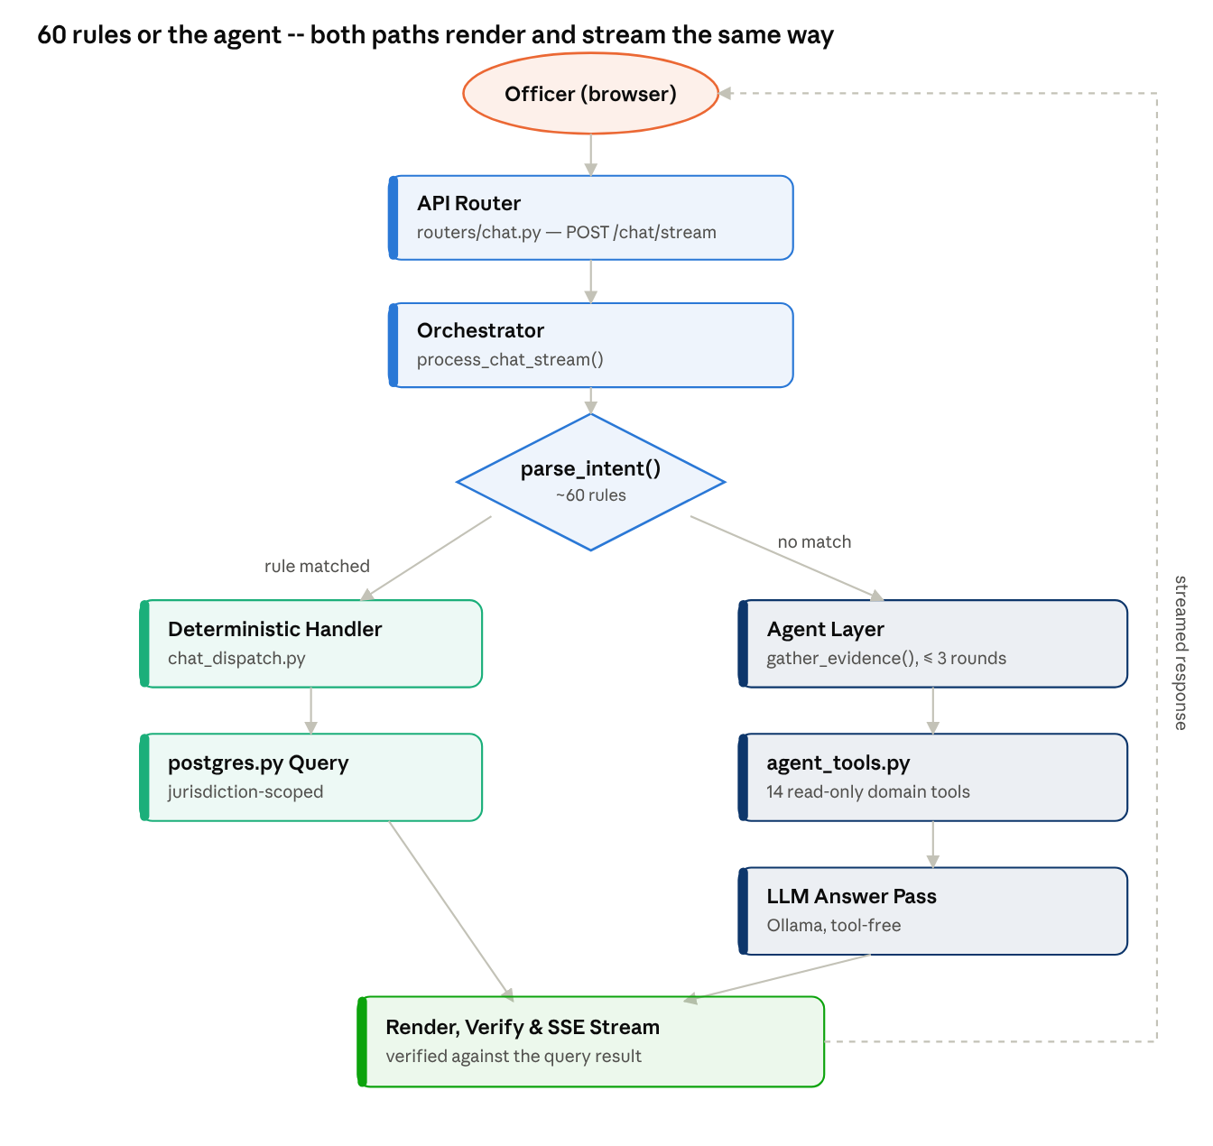
request flow · deterministic vs. agent path, both verified before streaming

4.2 Architecture Diagram
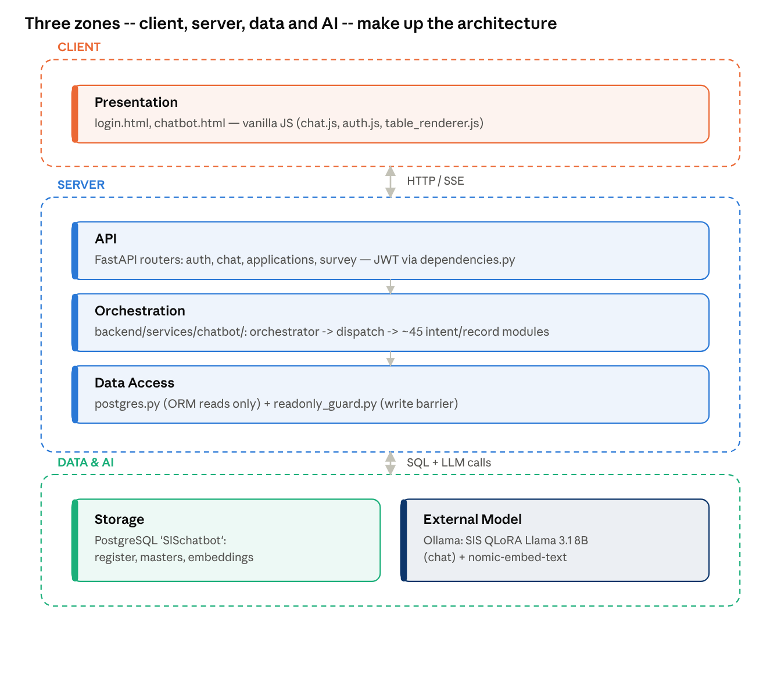
layered architecture · 6 layers, browser to local LLM

4.3 Data Flow Diagram
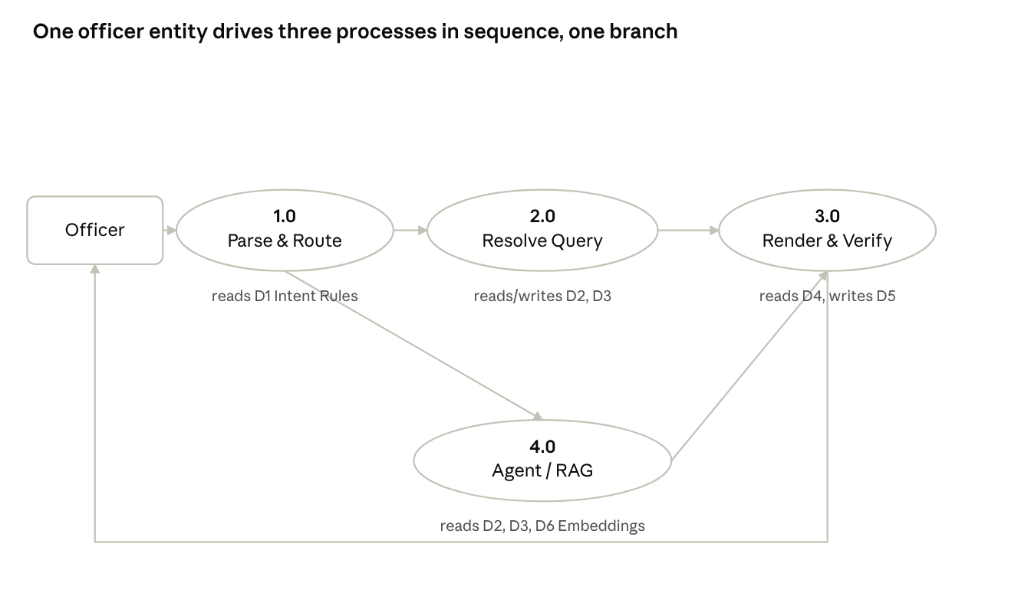
Level-1 DFD · 1 entity, 4 processes, 6 data stores
Process 1.0 either answers through 2.0/3.0 (a rule matched) or branches to 4.0 when none did; 4.0's result still returns through 3.0, so every answer — deterministic or agent-produced — is verified and rendered the same way before it reaches the officer.
Figure 4.3 — Level-1 DFD
External entity Officer sends a chat message to process 1.0 Parse & Route, which reads D1 Intent Rules and writes a resolved intent to 2.0 Resolve Query. 2.0 reads/writes D2 Application Register (applications, service_register_entries, workflow_history, field_visits) and D3 Geography Masters (district/taluk/town/ward/block), scoped by the officer's jurisdiction, and writes structured results to 3.0 Render & Verify, which also reads D4 Follow-up Context (prior turn's structured_data) and writes the final answer back to Officer while storing a copy in D5 Chat History. A branch from 1.0 to 4.0 Agent / RAG is taken when no intent rule matches; 4.0 reads D2, D3 and D6 Knowledge Embeddings (pgvector) before handing its result to 3.0 on the same path.

4.4 Use Case Diagram
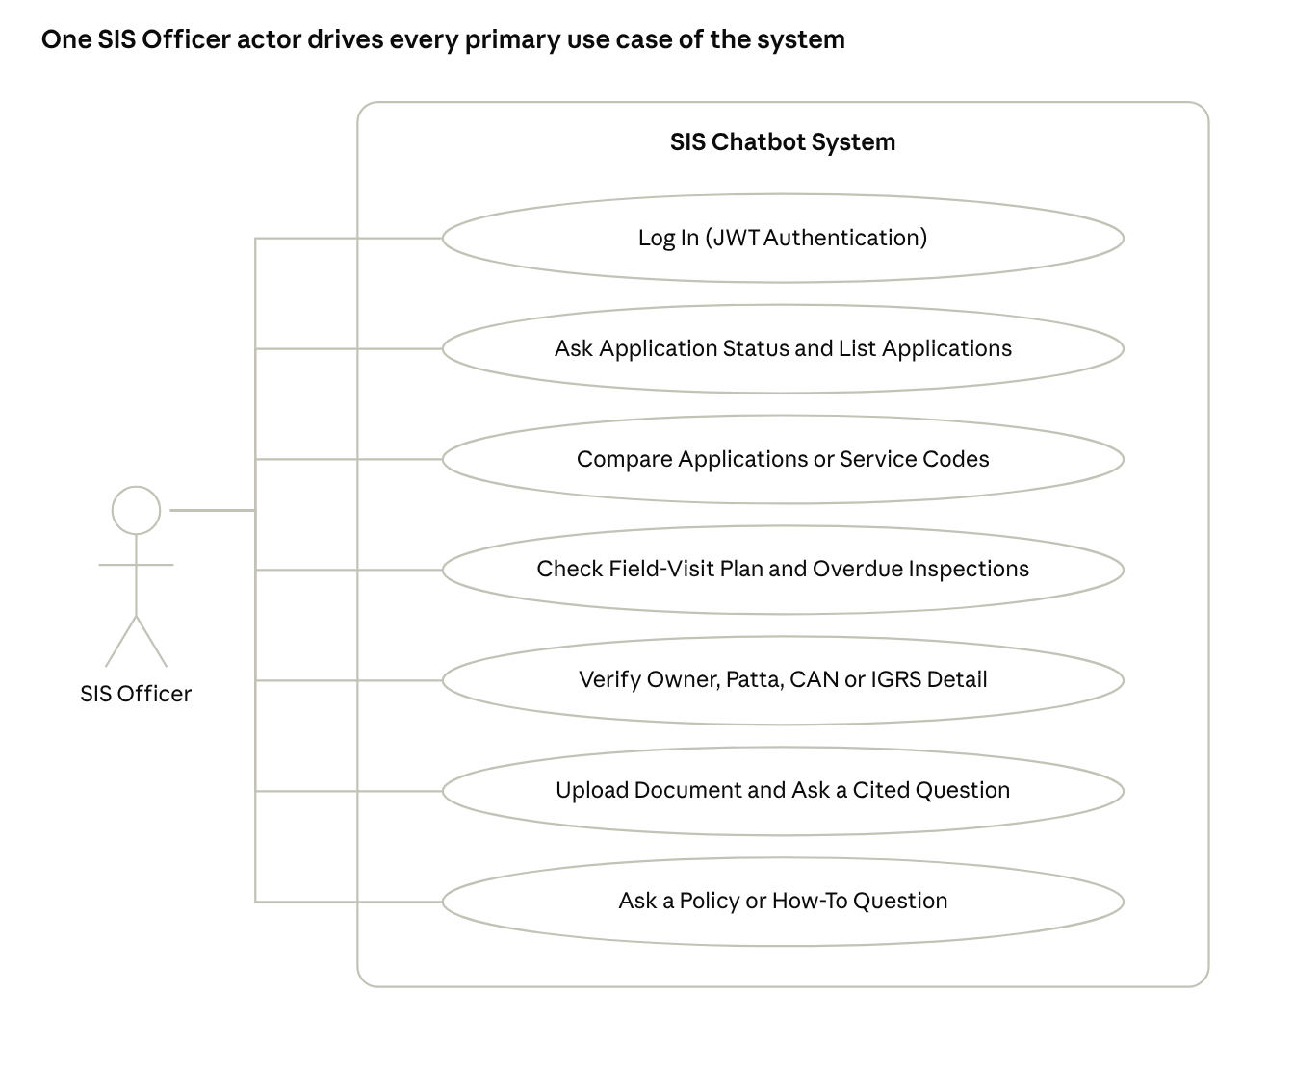
use case diagram · 1 actor, 7 primary use cases, system boundary
The SIS Officer is the sole actor; every primary use case sits inside the SIS Chatbot system boundary and is reached directly. Two relationships sit outside this drawing: (extends) a pronoun-less follow-up ("when was it approved?") extends Ask Application Status & List Applications, resolved from stored conversation context rather than a fresh actor action; (excludes) creating, modifying or deleting a register record is never a reachable use case — it is refused deterministically before intent routing and blocked again at the database layer by the read-only guard.

4.5 Activity Diagram
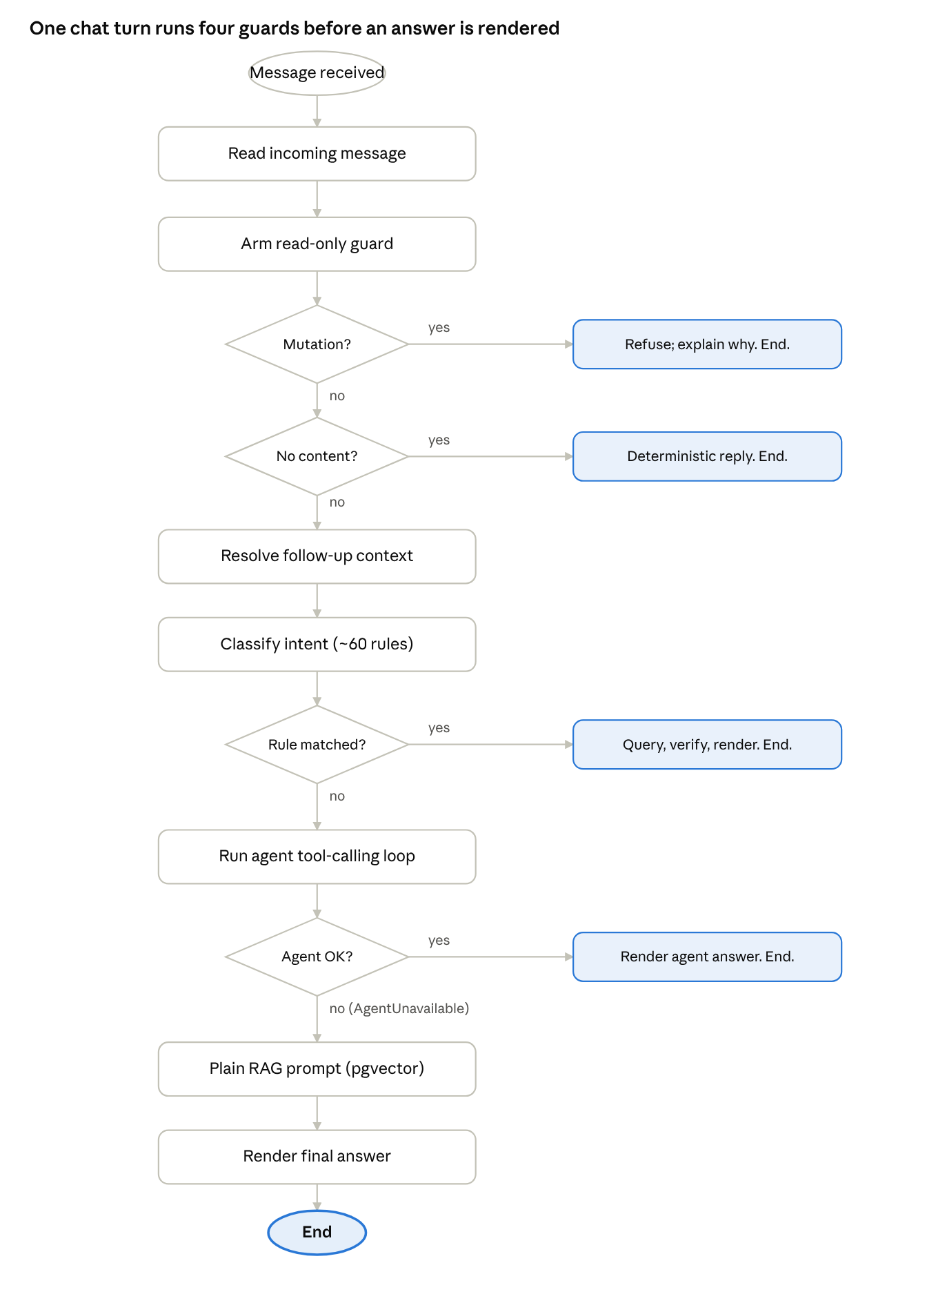
activity diagram · 4 guards, 1 chat turn

4.6 ISD Workflow Diagram
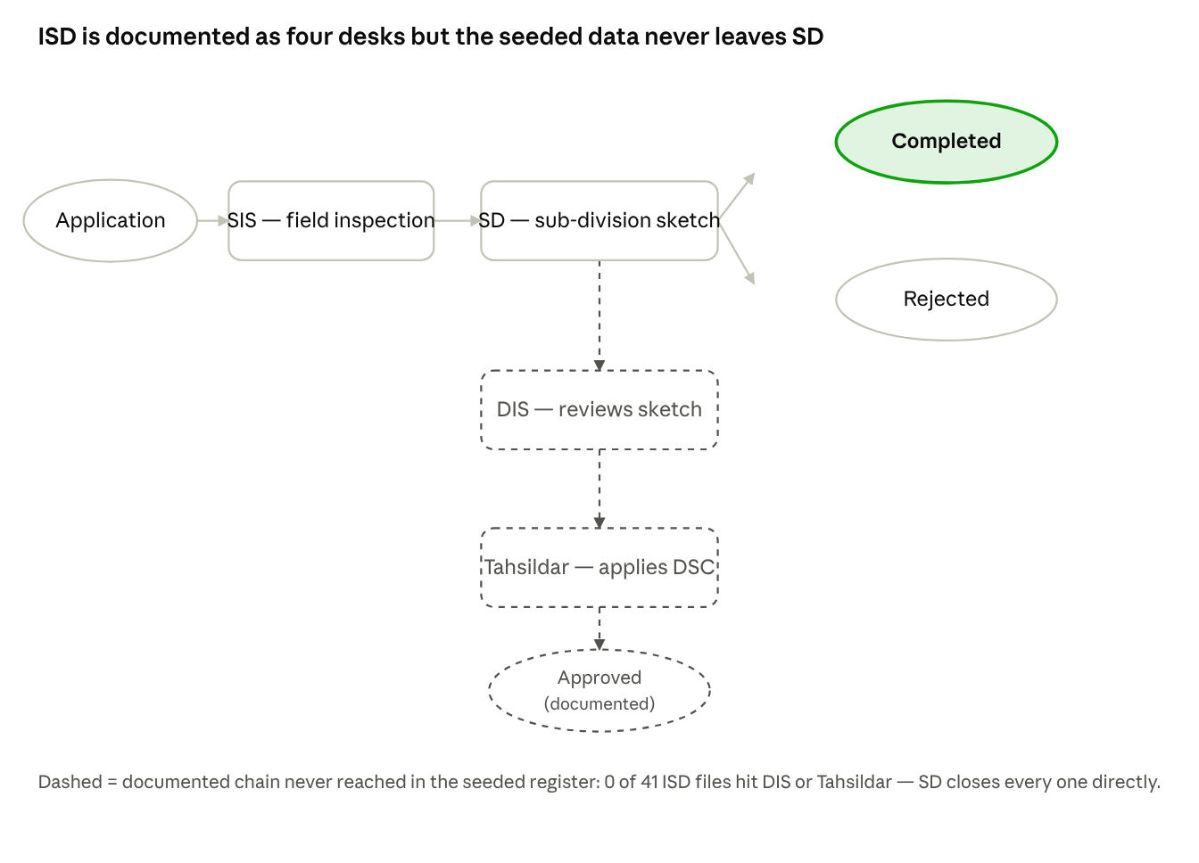
ISD workflow · 4 documented desks, SD closes the seeded files

4.7 NISD Workflow Diagram
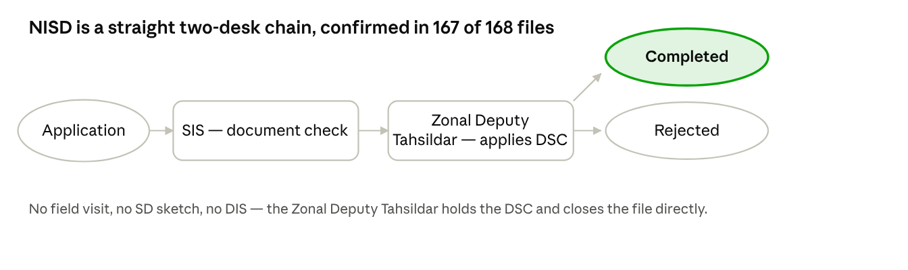
NISD workflow · 2-desk chain, confirmed by the data

4.8 Entity-Relationship (UML) Diagram
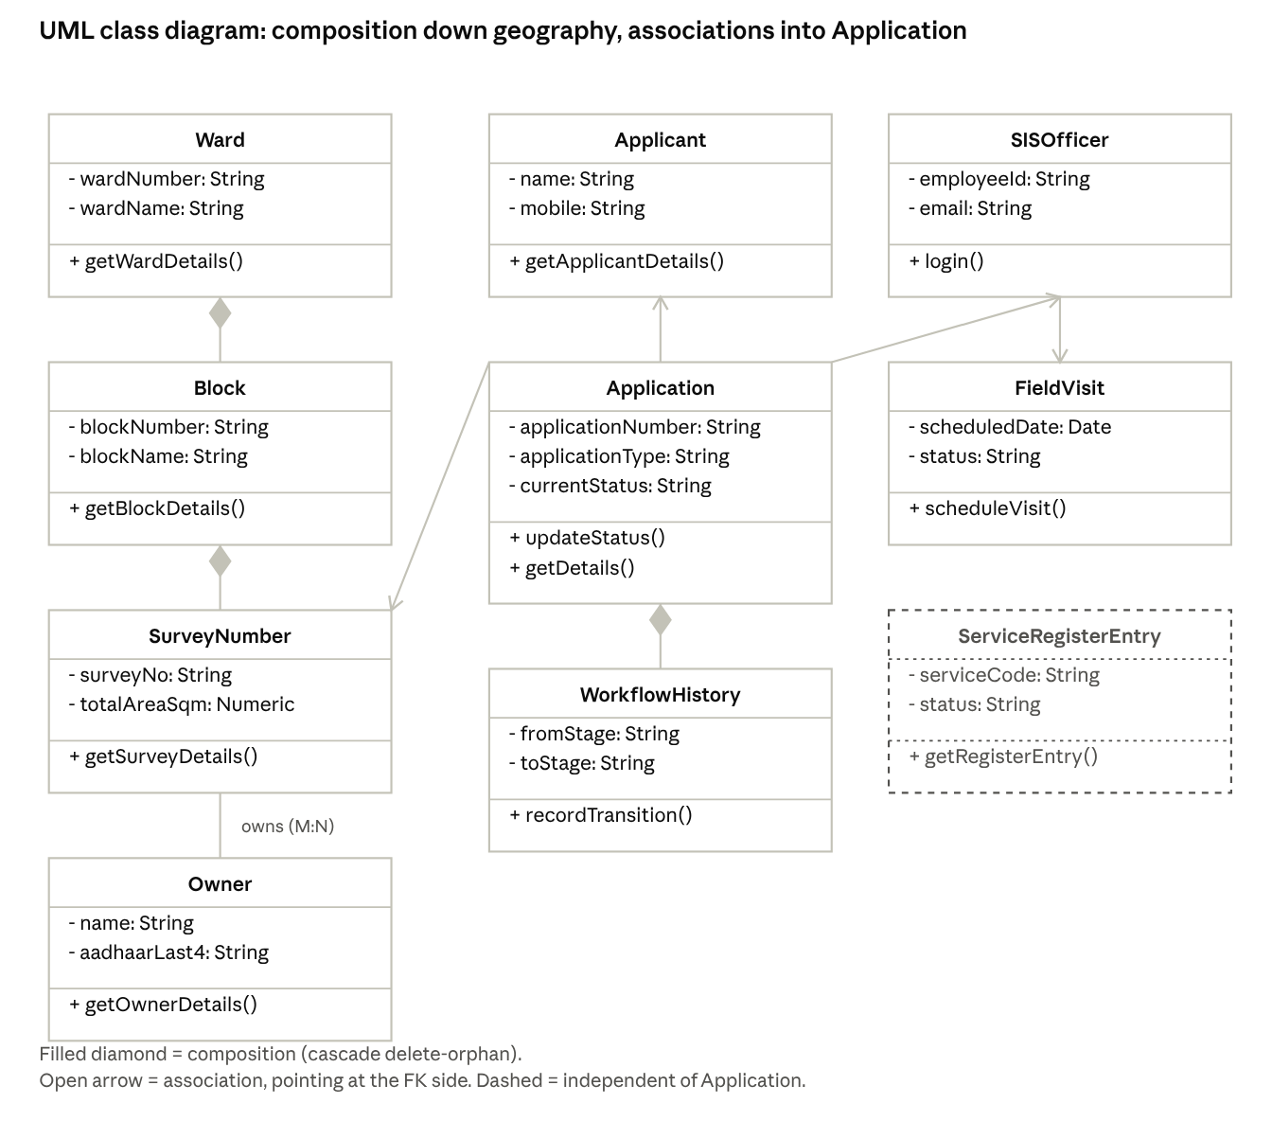
ER diagram · 9 core entities, geography to application register
NISD workflow · 2-desk chain, confirmed by the data

CHAPTER 5: SYSTEM SPECIFICATION

5.1 Hardware Requirements

Table 5.1: Hardware requirements
Component | Minimum | Recommended | Reason
RAM | 8 GB | 16 GB+ | Hosting a Q4_K_M-quantized 8B-parameter GGUF model in Ollama
CPU | 4 cores | 8 cores | Concurrent FastAPI request handling + LLM inference
GPU | None (CPU inference works) | CUDA-capable, 8 GB+ VRAM | Faster Ollama generation and embedding
Disk | 20 GB free | 50 GB+ free | Model weights (~4.6 GB GGUF), PostgreSQL data, document corpus
Client | Any device with a modern browser | — | Frontend is plain HTML/CSS/JS, no install needed

5.2 Software Requirements

Table 5.2: Software requirements
Layer | Technology | Version used
Language | Python | 3.8+
Web framework | FastAPI + Uvicorn | latest
ORM | SQLAlchemy (async) | 2.x
Database | PostgreSQL + pgvector extension | 12+
LLM runtime | Ollama | latest
Chat model | SIS QLoRA fine-tune of Llama 3.1 8B Tamil-Instruct (GGUF, Q4_K_M) | local
Embedding model | nomic-embed-text | via Ollama
Auth | python-jose (JWT) + passlib/bcrypt | latest
Logging | structlog | latest
Frontend | HTML5, CSS3, vanilla JavaScript (EventSource/SSE) | —
OS | Windows 11 / Linux | —

CHAPTER 6: MODULE DESCRIPTIONS

6.1 Project Structure
nic_internship/
├── backend/
│ ├── main.py # FastAPI app, lifespan, middleware, routers
│ ├── config.py # pydantic-settings (Settings class + DISTRICT_CODE_MAP)
│ ├── database.py # Async SQLAlchemy engine + Base + get_db()
│ ├── models.py # All SQLAlchemy ORM models (UUID PKs, TIMESTAMP(tz=True))
│ ├── schemas.py # Pydantic schemas (StandardResponse, OfficerContext, etc.)
│ ├── dependencies.py # get_current_officer() JWT dependency
│ ├── ingest.py # Document ingestion into pgvector (knowledge_embeddings)
│ ├── schema.sql # Raw SQL schema reference for the ORM tables
│ ├── routers/
│ │ ├── auth.py # POST /auth/login
│ │ ├── chat.py # POST /api/v1/chat/stream, GET /api/v1/chat/history
│ │ ├── applications.py # GET/PUT /applications
│ │ └── survey.py # Survey endpoints
│ ├── services/
│ │ ├── chatbot/ # The orchestrator package (formerly one ~29000-line chatbot.py,
│ │ │ │ # now split into ~45 modules under this directory):
│ │ │ ├── orchestrator.py # process_chat() / process_chat_stream() — main entry points
│ │ │ ├── chat_dispatch.py / _stream.py # routes a parsed intent to its deterministic handler
│ │ │ ├── chat_application_queries.py # all-service-code register listings/counts (ISD, NISD,
│ │ │ │ # and every other TAMILNILAM code alike)
│ │ │ ├── chat_shared.py # shared renderers (the all-service-code table, field maps)
│ │ │ ├── chat_followups.py / chat_smalltalk.py / chat_corrections.py / chat_routing.py
│ │ │ ├── agent.py, agent_tools.py # LLM tool-calling fallback (14 read-only domain tools)
│ │ │ └── *_qa.py # ~25 per-record-type handlers: owner, parcel, F-Line, TSLR,
│ │ │ # workflow, cross-checks, attachment Q&A, …
│ │ ├── rag.py # Intent detection (~60 intents), language detection, LLM calls
│ │ ├── postgres.py # DB-only query functions (ISD/NISD `applications` + the
│ │ │ # all-code `service_register_entries` register)
│ │ ├── followup_context.py # structured context for pronoun-less follow-ups
│ │ ├── attachment_store.py, doc_extract.py, csv_ops.py # uploaded-file handling
│ │ ├── pgvector_store.py, embeddings.py # knowledge_embeddings (RAG corpus)
│ │ └── readonly_guard.py # enforces that a chat turn can read the register but never write it
│ ├── sample_db/ # SISchatbot build pipeline — see backend/sample_db/README.md
│ │ ├── seed_sample_db.py # Creates the DB, applies DDL, generates + inserts rows
│ │ ├── verify_sample_db.py # Structure/refs/population/signature/non-leakage checks
│ │ ├── build_app_tables.py # Projects sample tables → the app's ISD/NISD ORM tables
│ │ ├── verify_identifiers.py # Checks every Aadhaar / CAN against identifiers.py
│ │ ├── identifiers.py # Aadhaar + CAN rules, shared by seed and projection
│ │ ├── check_app_wiring.py # Smoke test: app queries + chatbot answer from this DB
│ │ ├── question_bank.py # Shared question set for the suites
│ │ └── README.md # Source of truth for the DB layout
│ ├── sample_db_new/ # The pipeline that actually built the LIVE SISchatbot DB:
│ │ │ # adds the other ~27 service codes (F-Line, TSLR, correction/
│ │ │ # modification, …) sample_db/'s own seed never covered, and
│ │ │ # populates service_register_entries. Live table names drop
│ │ │ # the sample_db/ "_demo" suffix.
│ │ ├── build_app_tables_new.py # Projects sample_db_new's CSVs → the live DB tables
│ │ └── column_map.py # CSV-column → DB-column mapping for that projection
│ ├── documents/ # RAG corpus: workflow_guide.txt, faq_*.txt, survey_manual.txt
│ └── utils/
│ ├── fuzzy.py # Fuzzy month/token matching for typo tolerance
│ ├── helpers.py # Misc helpers
│ └── logger.py # structlog-based logger (get_logger)
├── frontend/
│ ├── login.html
│ ├── chatbot.html
│ ├── css/
│ └── js/
├── .env # Secrets (not committed)
├── .env.example # Template
├── requirements.txt
└── CLAUDE.md # Comprehensive AI assistant guide
The backend is organised in four layers — routers (HTTP), services/chatbot (orchestration), services/postgres.py (data access) and models.py (schema) — matching the layered architecture of Figure 4.2. Nothing outside services/postgres.py issues an ORM query directly.

6.1.1 Important Files Explained
File | Purpose
backend/main.py | FastAPI application entry point: creates the app, registers all routers, runs startup/shutdown lifespan hooks (DB connection, overdue-refresh scheduler, Windows UTF-8 stdout fix).
backend/config.py | pydantic-settings Settings class; every environment-dependent value (DB URL, secret key, Ollama URL, agent limits) is read from .env here and nowhere else.
backend/database.py | Builds the async SQLAlchemy engine and session factory; get_db() is the FastAPI dependency every route uses to obtain a scoped session.
backend/models.py | Every SQLAlchemy ORM model — Application, ServiceRegisterEntry, SISOfficer, Ward, ChatMessage, etc. — with their relationships and constraints; the single source of truth for the schema.
backend/schemas.py | Pydantic request/response schemas, including OfficerContext (the JWT-derived identity carried through every query) and StandardResponse.
backend/dependencies.py | get_current_officer(): decodes and validates the JWT, loads the officer and their jurisdiction, and is required by every protected route.
backend/ingest.py | One-shot CLI that embeds backend/documents/*.txt into knowledge_embeddings; also provides the OCR fallback (_ocr_page) that doc_extract.py reuses for scanned PDF uploads.
backend/routers/chat.py | POST /api/v1/chat/stream (SSE), /chat/upload, GET /chat/history — the only HTTP surface a chat message ever reaches the orchestrator through.
backend/routers/auth.py | POST /auth/login: verifies the bcrypt password hash and issues the JWT.
backend/services/chatbot/orchestrator.py | The largest single module: process_chat() / process_chat_stream(), the two functions every chat turn runs through end to end.
backend/services/chatbot/chat_dispatch.py / chat_dispatch_stream.py | Routes a classified intent to its deterministic handler; the non-streaming and SSE-streaming paths are kept as twin modules so a fix has to be applied, and tested, in both.
backend/services/chatbot/chat_application_queries.py | The all-service-code register listing/count logic (_register_listing()) and the per-code filter helpers — where the equal-treatment design (Chapter 3) is actually implemented.
backend/services/chatbot/chat_shared.py | Shared answer renderers used by several handlers: the all-service-code table, the field-keyword map, the mutation-request guard.
backend/services/chatbot/agent.py / agent_tools.py | The LLM tool-calling fallback and its 14 read-only, jurisdiction-checked tool implementations (Chapter 6.6).
backend/services/chatbot/followup_context.py (backend/services/followup_context.py) | Defines FollowupContext, reads and writes chat_messages.structured_data, and resolves a pronoun-less question against the previous turn.
backend/services/rag.py | parse_intent() (the ~60-rule router), detect_language(), and the LLM prompt-building / call_llama functions the plain RAG fallback uses.
backend/services/postgres.py | Every database query function the chatbot runs; the only module permitted to build a SQLAlchemy select() against the application register.
backend/services/readonly_guard.py | The before_flush / do_orm_execute SQLAlchemy event listeners that refuse any write to a non-conversation table during an armed chat turn.
backend/services/attachment_store.py / doc_extract.py / csv_ops.py | Upload storage and authorization, PDF/DOCX/CSV/TXT text extraction with located citations, and deterministic CSV arithmetic.
backend/services/pgvector_store.py / embeddings.py | similarity_search() over knowledge_embeddings, and the nomic-embed-text embedding calls that both ingestion and retrieval use.
backend/utils/helpers.py | SIS_URBAN_SERVICES (the 29-code catalogue), district code maps, and misc formatting helpers used across the codebase.
backend/utils/sla.py | The two SLA clocks (field-visit deadline, service completion window) and the working-day calculation both read from.
backend/sample_db_new/build_app_tables_new.py | The projection script that actually populated the live SISchatbot database from the extended CSV set, including service_register_entries.
frontend/js/chat.js | Opens the SSE connection, renders streamed tokens and result tables, and implements the "clear chat" and plain-text-to-card conversion the orchestrator's responses expect.
frontend/js/auth.js | Login form handling, JWT storage in sessionStorage, and attaching the Authorization header to every subsequent fetch.
.env | Every secret and environment-specific value (DB credentials, SECRET_KEY, LLM_MODEL, agent limits); never committed.
backend/services/chatbot/chat_smalltalk.py | Greeting/farewell/thanks classification, glossary ("what is FMB"), the contentless-message guard (clear/ok/ack), out-of-scope guard, and the rejected-widen-vs-narrow follow-up logic.
backend/services/chatbot/neg_scope.py | Parses negation over a list ("not rejected", "except ISD", "neither approved nor rejected") and filters the already-fetched rows accordingly.
backend/services/chatbot/qualifier_guard.py | Detects a list request with a word nothing can filter by ("applications in xyz") and asks the officer to clarify instead of silently falling back to the default queue.
backend/services/semantic_intent.py | Embedding-similarity classification of greetings/thanks/small talk for messages that carry no SIS vocabulary; returns None on any failure so the deterministic parser always has the final say.
backend/services/chatbot/calc_qa.py | Register-wide arithmetic: sums, differences, ratios, percentages, "which ward/month/code has the most", computed from the rows, never from the LLM.
backend/services/chatbot/othercode_detail.py | Assembles a one-card detail view for an application under any non-ISD/NISD service code, joining the register row with its workflow log and correction/modification data.
backend/services/chatbot/oldowner_qa.py, newowner_qa.py, igrs_owner_qa.py | The per-record-type owner handlers: chitta old-owner (ISD), full-field old/new owner (NISD), and IGRS Sub-Registrar owner records, each with its own field map and cross-checks against the other owner tables.
backend/services/chatbot/fline_qa.py, tslr_qa.py, sdattach_qa.py | F-Line (0178) record fields, TSLR sketch (0156) record fields, and the SD sketch-attachment metadata for ISD files — the record families outside the ISD/NISD workflow table.
backend/services/chatbot/howto_qa.py | Policy/how-to questions (required documents, the 15-working-day rule, rejection reasons) answered deterministically from workflow_guide.txt / land_rules.txt, reached before the LLM for about 90% of what used to need it.
backend/services/chatbot/card_html.py | Renders every record-module answer as the same titled FIELD | DETAILS card with a Copy button, so a deterministic answer and an application-status card look identical to the officer.
backend/utils/translit.py | Deterministic Tamil ↔ Latin name transliteration, used to compare an applicant's name against an owner's name written in a different script.
backend/sample_db_new/column_map.py | Maps each source CSV's raw column names to the live database's column names for the projection that actually built the SISchatbot register.
test_servicecode_equal_treatment.py, test_negation_scope.py, test_followup_context.py | Representative regression suites: equal treatment across all 29 service codes, negation-over-lists correctness, and structured follow-up resolution — the project ships over 60 such scripts.
backend/test_200_suite.py | A 200-question backend regression set spanning every major intent family, run end to end through process_chat().

6.2 Authentication and Session Module
routers/auth.py, services/auth_service.py, dependencies.py. Validates officer credentials (bcrypt-hashed password), issues a JWT carrying the officer id and jurisdiction, and exposes get_current_officer() as a FastAPI dependency every protected route requires. get_officer_jurisdiction_ids() resolves the officer's ward/block/town/taluk/district ids once per request, which every downstream query filters on.

6.3 Orchestrator Module
services/chatbot/orchestrator.py and chat_dispatch.py / chat_dispatch_stream.py. process_chat() / process_chat_stream() are the single entry points for a chat turn: they arm the read-only guard, run the mutation/contentless/out-of-scope guards, resolve follow-up context, classify intent, dispatch to a handler, verify any LLM-written numbers against the query result, and persist the turn to chat_messages.

6.4 Intent and Language Detection Module
services/rag.py, rag_language.py, semantic_intent.py. parse_intent() resolves roughly sixty intents by token-boundary and edit-distance matching across English, Tamil and Tanglish; detect_language() classifies the message script; semantic_intent.classify() uses nomic-embed-text similarity to catch greetings/thanks/small talk that carry no SIS vocabulary, standing aside the moment a real question is detected.

6.5 Database Query Module
services/postgres.py. The only module that issues ORM queries against the application register. Every function takes an OfficerContext and filters on officer.jurisdiction_ids; functions such as get_all_service_code_applications() cover every TAMILNILAM service code generically, while get_officer_applications() covers the ISD/NISD workflow table specifically.

6.6 Agent / Tool-Calling Module
services/chatbot/agent.py, agent_tools.py. Implements the fallback tool-calling loop (Algorithm C) over fourteen read-only domain tools, each a thin wrapper around a postgres.py function. validate_args() rejects any officer/jurisdiction/SQL-shaped argument outright, so authorization is never delegated to the model.

6.7 Attachment and Document QA Module
services/attachment_store.py, doc_extract.py, csv_ops.py, services/chatbot/attachment_qa.py. Extracts PDF/DOCX/CSV/TXT uploads into located segments (page/paragraph/row), stores them per-session with a 15-minute retention window, computes CSV arithmetic deterministically, and refuses to answer (no LLM call) when retrieved evidence falls below a lexical overlap floor.

6.8 Vector Store and Embedder Module
services/pgvector_store.py, services/embeddings.py, backend/ingest.py. ingest.py loads the department's policy documents into knowledge_embeddings (768-dimensional nomic-embed-text vectors, HNSW index, cosine similarity); pgvector_store.similarity_search() is the only retrieval path the agent's search_documents tool and the plain RAG fallback use.

6.9 Feature Catalogue
Every major feature of the system, what it does, and where it lives in the codebase.
Feature | What it does | Where
Bilingual intent routing | Resolves ~60 intents by token-boundary + edit-distance matching across English, Tamil and Tanglish, tolerant of typos in all three | rag.py: parse_intent()
All-service-code equal treatment | Listings, counts, status filters and comparisons answer every TAMILNILAM code alike from one flat register, not just ISD/NISD | postgres.py: get_all_service_code_applications(), chat_application_queries.py
Follow-up context resolution | Answers pronoun-less questions ("which is oldest?", "when was it approved?") from structured context stored on the prior turn, not by re-scraping rendered text | followup_context.py, chat_followups.py
Negation over lists | Understands "not rejected", "except ISD", "neither approved nor rejected", "without a field visit" as filters on an existing list | neg_scope.py
Agent tool-calling fallback | A bounded LLM loop over 14 authorized, jurisdiction-checked read-only tools, for questions no deterministic rule matches | agent.py, agent_tools.py
LLM number verification | Strips or corrects any count or application number an LLM-written sentence states that disagrees with the query it was given | chat_followups.py: _verify_answer_numbers()
Read-only guard | SQLAlchemy event listeners refuse any write to a departmental table for the whole duration of a chat turn | readonly_guard.py
Jurisdiction scoping | Every query filters on the officer's own ward/block ids; a ward not held is refused by name, not silently emptied | postgres.py, agent_tools.py
Chat attachments with cited evidence | Extracts PDF/DOCX/CSV/TXT uploads into located segments; answers cite a page, paragraph or row; a question with no matching evidence is refused, never guessed | attachment_store.py, doc_extract.py, attachment_qa.py
Deterministic CSV arithmetic | Count/sum/min/max/group over an uploaded CSV is computed in code, never narrated by the LLM; a formula-looking cell is never evaluated | csv_ops.py
Field-visit SLA tracking | The 15-working-day ISD field-visit deadline and the 15–35-day service SLA are tracked and refreshed every 6 hours, working-day aware | backend/utils/sla.py, overdue_refresh.py
Active-application lock | Refuses a second application on a survey number while one is already open, across sub-divisions | postgres.py: check_survey_application_lock()
Comparison engine | Seven comparison shapes (applications, type, status, channel, ward, period, superlative) all answered from the register, typo-tolerant | rag.py: parse_comparison_query(), chat_dispatch.py
Mutation refusal | A request shaped like an imperative that names a register object is refused deterministically, before any handler runs, and never falsely claims an action happened | chat_shared.py: _is_mutation_request()
Out-of-scope / capability guard | Off-topic questions (weather, poems, arithmetic) and "what can you do" get a one-line deterministic answer, never an LLM-generated aside | chat_smalltalk.py
Service-code lookup and comparison | "what is 0153?", pairwise comparison of any two of the 29 codes, and prefix/catalogue questions, all answered from SIS_URBAN_SERVICES without an LLM call | chat_service_codes.py
Bilingual LoRA fine-tune | A QLoRA adapter over Llama 3.1 8B Tamil-Instruct, trained on SIS-specific phrasing with no live application/CAN numbers in the data | lora_training/, see 7.8
Contentless-message handling | "clear", "ok", typing filler and session commands are answered deterministically with zero LLM/tool calls | chat_smalltalk.py: _contentless_message()

6.10 Database Tables
The schema (backend/models.py) in three groups, matching the ER diagram (Figure 4.8).
Geography masters — statewide, department-wide reference data, shared by every officer:
Table | Key columns | Explanation
district_unicode | district_code, district_name, app_uid | TAMILNILAM district master, loaded verbatim from the department's own pg_dump; app_uid is a deterministic (md5-derived) UUID so a reload never breaks a foreign key.
taluk | taluk_code, district_uid, app_uid | Taluk master, same deterministic-UUID treatment as the district table.
towns | taluk_id, name, town_code | Town/urban unit, the level at which an SIS jurisdiction is usually granted.
wards | town_id, ward_number, ward_name | The ward an application belongs to; the unit most officer jurisdictions are scoped at.
blocks | ward_id, block_number, block_name | The finest geography unit; a survey number belongs to exactly one block.
Parcel and ownership — the land record itself:
Table | Key columns | Explanation
survey_numbers | block_id, survey_no, total_area_sqm, patta_number, has_encroachment, has_litigation | One row per town survey number; carries the parcel's area, patta and flags an officer checks before approving a mutation.
sub_divisions | survey_number_id, sub_division_no, area_sqm, status | A split of a survey number created by an ISD application (e.g. 145/1A).
owners | name, name_tamil, father_name, relationship_type, aadhaar_last4, gender | A person recorded against a parcel in the natham-chitta register; Aadhaar is stored only as its last 4 digits and the chatbot never states even that, only "recorded" or "not recorded".
survey_ownership | survey_number_id, sub_division_id, owner_id, ownership_share, ownership_type | The many-to-many join between parcels and owners, with the share each owner holds.
Application and workflow — what the chatbot actually answers questions from:
Table | Key columns | Explanation
applicants | name, mobile, aadhaar_last4, father_name, occupation | The person who filed an ISD/NISD application (distinct from owners, who may be a different person — the applicant is usually the new owner).
applications | application_number, application_type (ISD/NISD), submission_channel, current_stage, current_status, can_number, fee_amount | The full workflow-tracked table; ck_application_type restricts it to service codes 0153/0154 only, by design (Chapter 3).
service_register_entries | application_number, service_code, status, stage, ward_id | The flat, all-29-code register (Chapter 1.2.1) that every other service code is answered from; no workflow or applicant detail, by design.
workflow_history | application_id, from_stage, to_stage, action, performed_by_officer_id, performed_at | One row per desk hop; performed_at (not action_date) orders a file's history correctly even when three desks clear it the same day.
field_visits | application_id, officer_id, scheduled_date, actual_date, status, encroachment_found | Tracks the mandatory ISD field inspection; NISD files never get a row here.
patta_transfers | application_id, survey_number_id, previous_owner_id, new_owner_id | The actual ownership change an approved application produces.
sis_officers | employee_id, email, password_hash, designation | Officer login identity.
officer_jurisdictions | officer_id, jurisdiction_type, ward_id, block_id | What geography an officer may query; every postgres.py function filters on this, never on a client-supplied ward.
chat_sessions / chat_messages | session_id, role, content, structured_data, response_time_ms | The conversation itself; structured_data is what makes a pronoun-less follow-up resolvable (Chapter 6.4).
knowledge_embeddings | chunk_id, embedding (vector(768)), content | The pgvector-indexed policy-document corpus the RAG fallback retrieves from.

6.11 File Upload Feature — Detailed
Officers can attach a file to the chat and ask questions about it, with every answer traceable to a specific page, paragraph or row rather than paraphrased from memory. This replaced an earlier design that parsed an upload to a flat string, kept it in a module-level dict, pasted the first 16,000 characters into the prompt, and lost everything on a server restart.
Supported formats and extraction. POST /api/v1/chat/upload accepts PDF, DOCX, CSV and plain text, each parsed with a native library (pypdf, python-docx, csv.DictReader) rather than a generic text dump:
Format | Extraction | Location citation
PDF (text layer) | pypdf page-by-page | "file.pdf, page 3"
PDF (scanned, < 20 selectable chars/page) | Tesseract OCR, English + Tamil (eng+tam) | "file.pdf, page 3" (marked as OCR'd)
DOCX | python-docx paragraph/table extraction | "file.docx, paragraph 12" / "table 2"
CSV | csv.DictReader, rows kept verbatim for arithmetic | "file.csv, rows 18–24"
TXT | Exact physical line numbers | "file.txt, line 40"
Image files (PNG/JPG/etc.) | Rejected at upload — "Images are not read; this assistant reads text only" | n/a
Legacy .doc, audio, video | Rejected at upload | n/a
Storage. The file's bytes are written under a server-generated uuid4().hex name inside var/attachments/ (gitignored, outside anything the web server serves) — the client's own filename never touches a path. Extracted text is split into attachment_chunks (the retrievable evidence, each with its location and a ready-made citation string) and, for CSV, into attachment_rows (verbatim rows for computation). A document re-uploaded with the same bytes in the same chat (matched by content_hash) reuses the existing record and simply renews its retention window.
No evidence, no LLM call. Every question about an attachment is first scored against the retrieved chunks by UPLOAD_MIN_EVIDENCE_SCORE (0.4) — the share of the question's content words the chunk actually carries. Below that floor the answer is exactly "I could not find this in the uploaded document" and the model is never invoked, because there is nothing for it to speculate from. The floor is lexical, not vector-similarity, so it still holds if Ollama is down; the embedding layer only re-ranks chunks that already pass the word-overlap check and can never manufacture evidence on its own.
CSV questions are computed, never narrated. csv_ops.parse_csv_question() recognises count / filter / group / sort / min / max / sum / average / row-lookup shapes and executes them directly over attachment_rows; the rendered answer carries the exact row numbers that matched. A cell that looks like a formula (=SUM(D2:D5), a leading @, +, or -) is treated as literal text and never evaluated — the same defence used against CSV-injection attacks. When the parser cannot tell which column is meant, it returns nothing rather than guessing, and the question falls through to ordinary retrieval.
Citations are rendered from stored metadata, never invented by the model. doc_extract.citation_label() turns a stored location into a string such as "order.pdf, page 3" or "register.csv, rows 18–24", and the model is only ever handed the finished string to copy into its answer. Two separate page locations are never merged into one range ("pages 1–3" on a 3-page document is the same as no citation at all), and a chunk whose location cannot be resolved is presented with no citation rather than a vague one.
Authorization. The officer comes from the JWT, never from the request body. The session is verified against that officer before anything is parsed, and every chunk/row query additionally filters on officer and session — denormalised onto the chunk rows themselves, so a join bug cannot silently widen access. A document_id supplied by the client is a lookup key, never a grant: another officer's document reads back as "does not exist", not as a permission error that would confirm it exists.
Retention. Every row carries expires_at (UPLOAD_RETENTION_MINUTES, 15 minutes). A sweep runs at server startup, on every new upload, and every UPLOAD_SWEEP_INTERVAL_SECONDS (60s); reads also ignore rows past their expiry. Because the store is PostgreSQL rather than an in-process dict, a server restart loses nothing that has not already expired — the exact failure mode the earlier design had.
Routing — an attachment must not swallow the register. targets_attachment() claims a chat turn only when the message names a file, uses attachment wording (English, Tamil or Tanglish), or the intent is the general_query fallback — the one case where the alternative is handing the LLM an ungrounded prompt anyway. A question that names an explicit application number, or that routes to a deterministic SIS intent ("how many applications are approved?"), always stays on the register path; an officer who means the file says so ("...in register.csv").
Mixed-language support. The evidence-floor word match is script-aware: a Tamil question about an English-language order copy used to score zero content-word overlap and refuse by default. _ALIASES in attachment_store.py maps common SIS vocabulary across scripts (e.g. ஒப்புத↔approved, கட்டண↔fee), Tamil interrogatives and passive-participle grammar are excluded from the word-overlap count rather than penalised as "unmatched", and Tamil matching is substring-based throughout (the same virama-boundary issue documented for the intent router elsewhere in this codebase).
A survey number from an attachment carries its subdivision number too, the same rule the database-backed survey_detail intent follows: survey_subdivision_pairs() scans the text after each survey-number match for a paired subdivision number (never guessing one that is not stated), and the equivalent CSV logic pairs columns by header name so a rendered row never silently drops a subdivision figure.

CHAPTER 7: SOFTWARE DESCRIPTION

7.1 Python
Chosen for its async ecosystem (SQLAlchemy 2.x async, FastAPI) and its strength in NLP/text-processing glue code, which this project needs heavily for intent regexes, fuzzy matching and LLM prompt assembly.

7.2 FastAPI
Provides native async/await request handling, automatic OpenAPI docs (/api/docs), and first-class Server-Sent-Events support for the streaming chat endpoint — lighter-weight than Django for an API-only backend with no server-rendered pages.

7.3 Ollama
Runs the quantized GGUF model locally with no external API dependency — a requirement for a government department's data to never leave department infrastructure. Serves both the chat model (SIS QLoRA fine-tune) and the embedding model (nomic-embed-text) behind one local HTTP endpoint.

7.4 PostgreSQL
Chosen over a document database because the application register is inherently relational (applications → owners → survey numbers → workflow history, each with real foreign keys) and because pgvector lets the same database also serve as the RAG vector store, avoiding a second infrastructure component.

7.5 pgvector
Adds a native vector column type and HNSW approximate-nearest-neighbour index to PostgreSQL, so knowledge_embeddings sits beside the relational tables rather than in a separate ChromaDB/Qdrant deployment — one database, one backup policy, one connection pool.

7.6 SQLAlchemy (async)
The ORM layer every query in postgres.py goes through; its before_flush and do_orm_execute event hooks are what readonly_guard.py uses to refuse a write at the engine level, not just by convention in application code.

7.7 python-jose / passlib
Standard, well-audited libraries for JWT issuance/verification and bcrypt password hashing, avoiding a hand-rolled authentication scheme for a system handling government personnel credentials.

7.8 Why Llama 3.1 8B Tamil-Instruct
Four constraints narrowed the model choice, in order:
- On-premises only. A government department's application data, owner names and Aadhaar-adjacent identifiers cannot leave department infrastructure to a hosted API. This rules out GPT-4/Claude-class hosted models outright and requires a model that runs fully offline through Ollama.
- Tamil competence out of the box. Officers write mostly in Tamil or Tanglish. A base Llama 3.1 8B Instruct model is English-centric; mervinpraison/Llama-3.1-8B-Instruct-Tamil was downloaded from Hugging Face Hub (huggingface.co/mervinpraison/Llama-3.1-8B-Instruct-Tamil) as the base checkpoint for the project's own QLoRA pass, and is itself an Unsloth/TRL SFT of the same base specifically continued on Tamil instruction data, giving a materially better starting point for Tamil phrasing than fine-tuning the English base from zero. (Its model card itself makes no explicit Tamil claim and is tagged English, so this is a starting point to improve on, not a finished Tamil model — which is exactly what the project's own SIS QLoRA pass over it is for.)
- Fits the hardware budget. 8B parameters, quantized to Q4_K_M GGUF (≈ 4.6 GB), runs acceptable-latency inference on a department workstation with 16 GB RAM and no GPU requirement — a 70B-class model would need server-grade hardware the department does not have, and a smaller (1–3B) model does not reliably hold instruction-following quality once quantized and fine-tuned on a narrow domain.
- QLoRA fine-tuning is feasible at this size. An 8B base lets the project's QLoRA adapter (Chapter 2.2) train on a single Colab L4 GPU in hours, not days — a 70B base would need multi-GPU infrastructure this project does not have access to, for a domain (land-mutation status answers, not open-ended reasoning) that does not need a frontier-scale model's broader capability.
The deterministic router answers the large majority of real questions without reaching the model at all (Chapter 10.6), so the LLM's job is narrower than "be a general assistant" — it only needs to phrase a grounded answer well in three scripts and pick the right tool in the agent loop, both of which an 8B instruction-tuned model, fine-tuned on in-domain data, does adequately. LLM_MODEL in .env still defaults to stock llama3.1:8b until the SIS QLoRA adapter is merged, quantized and registered as an Ollama model, so the system degrades gracefully to the untuned base rather than failing to start.

7.9 Model and Retrieval Parameters
Every value below is read from backend/config.py / backend/ingest.py, not estimated.

Generation (rag_llm.py, ChatOllama)
Parameter | Value | Why
num_ctx (input context window) | 16,384 tokens | Large enough to hold the system prompt, the full conversation history, retrieved document chunks and structured DB context in one call without silent truncation on the input side. Raised from Ollama's smaller default after longer multi-turn conversations were losing earlier context.
num_predict (max output tokens) | 256 tokens | Caps a generated answer to roughly a long paragraph. Ollama's own default (128 on many builds) was cutting replies off mid-sentence; 256 was chosen as the smallest increase that stopped truncation on real SIS answers without letting the model ramble.
AGENT_FOLLOWUP_MAX_TOKENS | 64 tokens | A separate, tighter cap used only for the agent's short follow-up/clarification generations, where a multi-paragraph reply would never be appropriate.
temperature | 0.1 | Low by design: the LLM's job here is to phrase a grounded answer consistently from supplied facts, not to write creatively — a higher temperature would reintroduce the risk of a reworded number or an invented detail.
keep_alive | LLM_KEEP_ALIVE (configurable) | Keeps the model resident in Ollama between questions; an idle unload previously cost a 15-second reload on the next document question.

Retrieval and chunking — two separate pipelines with separate tuning
Parameter | RAG corpus (ingest.py) | Chat attachments (config.py)
Chunk size | 2,000 characters (≈ 500 tokens) | UPLOAD_CHUNK_CHARS = 1,200 characters
Chunk overlap | 200 characters | UPLOAD_CHUNK_OVERLAP = 150 characters
Splitter | RecursiveCharacterTextSplitter, splitting on "\n=== " section headings first, then paragraph/line/sentence/word boundaries | Format-specific: PDF by page, DOCX by paragraph/table, CSV by row, TXT by physical line
Retrieval top-k | top matches re-ranked by cosine similarity, no fixed k exposed as a setting | UPLOAD_RETRIEVAL_TOP_K = 6 chunks
Embedding model / dimension | nomic-embed-text, 768 dimensions, HNSW cosine index | same
The two pipelines are deliberately different sizes: the policy-document corpus is long-form prose where a 2,000-character chunk keeps a whole explanation together, while an uploaded register extract is often tabular or short-form, where a smaller 1,200-character chunk with proportionally less overlap (150 vs. 200) keeps citations precise to a narrower span of the source file. The "\n=== " section-heading split on the RAG corpus specifically exists because a plain character-count split once separated a line like "Total Timeline: Approximately 30–35 working days" from the === ISD WORKFLOW === heading above it, letting the model quote an NISD timeline for an ISD question; _prefix_section_headings() now re-attaches the owning heading to any chunk that does not already start with one.

CHAPTER 8: SYSTEM TESTING

8.1 Unit Testing
Routing-only suites (test_intent_coverage, --routing flags across most test_*.py scripts) exercise parse_intent() and individual classifier functions with no database or LLM call, so they run in well under a second and catch a regex regression immediately. Example: test_distinct_service_count_routing.py asserts that a single-code count question ("how many service code 0158 applications do I have?") is never misrouted into the distinct-service-code meta-counter.

8.2 Integration Testing
DB-backed suites (test_followup_context.py, test_servicecode_equal_treatment.py, test_channel_queries.py, test_negation_scope.py, and over fifty others) run real queries against the live SISchatbot database through postgres.py, verifying that a rendered answer's figures match an independently-computed SQL count.

8.3 System Testing
End-to-end suites call process_chat() / process_chat_stream() directly, the same entry points the API uses, with the LLM and embedding calls mocked where only the deterministic path is under test, or live where bilingual LLM-fallback quality is being checked (test_200_suite.py, test_comprehensive_suite.py).

8.4 Test Cases

Table 8.1: Representative test cases
ID | Scenario | Input | Expected result | Status
TC-01 | Single service-code count | "How many service code 0158 applications do I have?" | Count matches service_register_entries for code 0158, label not falsely "pending" | Pass
TC-02 | Narrow vs. widen on rejected | "show rejected one" after a count that hid rejected files | Returns only the rejected rows, scoped to the same service code | Pass
TC-03 | Widen phrasing preserved | "include rejected too" after a pending listing | Returns every status, same scope | Pass
TC-04 | Jurisdiction isolation | Officer A requests an application outside their ward | Refused as out of jurisdiction, not "not found" | Pass
TC-05 | Mutation refusal | "delete all my applications" | Refused deterministically; zero chat_messages write of a mutation | Pass
TC-06 | Bilingual equivalence | Same question asked in English and in Tamil | Same underlying data, script-matched reply language | Pass
TC-07 | Follow-up resolution | "when was it approved?" after a status answer | Resolves the application from context, returns the decision date | Pass
TC-08 | Attachment evidence floor | A CSV question with no matching column | Refuses rather than guessing a column | Pass
TC-09 | Read-only guard | A crafted ORM UPDATE inside a chat turn | Refused by before_flush listener before reaching PostgreSQL | Pass
TC-10 | Agent authorization | Agent attempts a tool call with an officer-shaped argument | Call rejected by validate_args(), never reaches the database | Pass

CHAPTER 9: SOURCE CODE

9.1 Configuration (backend/config.py)
class Settings(BaseSettings):
# Database
DATABASE_URL: str
SYNC_DATABASE_URL: str
# Security
SECRET_KEY: str
ALGORITHM: str = "HS256"
ACCESS_TOKEN_EXPIRE_MINUTES: int = 480
# Agent
AGENT_ENABLED: bool = True
AGENT_MAX_ITERATIONS: int = 3
AGENT_TIMEOUT_SECONDS: int = 90
pydantic-settings reads every runtime value from .env; nothing is hardcoded, so the same code deploys against a different district's database by changing DATABASE_URL alone.

9.2 Read-only guard (backend/services/readonly_guard.py)
# A chat turn arms a contextvar (not a flag -- each request is its own
# task with its own context) and two SQLAlchemy listeners refuse anything
# outside the allow-list of conversation tables.
@event.listens_for(Session, "before_flush")
def _refuse_orm_write(session, flush_context, instances):
if not _CHAT_TURN_ACTIVE.get():
return
for obj in session.new | session.dirty | session.deleted:
if type(obj).__tablename__ not in _ALLOWED_TABLES:
raise ReadOnlyViolation(type(obj).__tablename__)
This is what turns "the audit found no write path" into a runtime guarantee: a future handler that "helpfully" updates a status fails loudly instead of succeeding quietly.

9.3 Service-code count routing fix (backend/services/chatbot/chat_application_queries.py)
def _asks_distinct_service_count(message: str) -> bool:
"""'How many services currently have pending applications?' counts
SERVICES, not applications. A single named code ('how many service
code 0158 applications do I have?') is a single-code application
count, not a count of codes -- `find_service_codes` catches that case
and stands aside, leaving it to the ordinary count-only renderer."""
from backend.utils.helpers import find_service_codes
if find_service_codes(message):
return False
return bool(_DISTINCT_SERVICE_COUNT_RE.search(message or ""))
The guard clause is the important line: a service code named in the message is conclusive proof the officer wants a single-code application count, never a count of how many codes exist — so it is checked first and unconditionally, before the looser "how many service code(s)" wording ever gets a chance to misclassify the question. The same principle recurs across the codebase: the narrowest, most specific signal in a message always outranks a broader keyword match.

9.4 Agent tool authorization (backend/services/chatbot/agent_tools.py)
_FORBIDDEN_ARGS = {"officer", "officer_id", "jurisdiction", "jurisdiction_ids", "sql", "query"}
def validate_args(tool_name: str, args: dict) -> dict:
for forbidden in _FORBIDDEN_ARGS & args.keys():
raise ToolArgumentError(f"{tool_name}: model may not set '{forbidden}'")
# ... ward/block arguments are checked against the officer's own
# jurisdiction before the query runs; a ward not held is refused by
# name, never silently passed through to an empty-result query.
return cleaned_args
Authorization is enforced here, not learned by the model: the officer and their jurisdiction are bound out of band by ToolContext, and no tool schema accepts them as a parameter at all.
Every query below is jurisdiction-scoped in the real code (:ward_ids is the officer's own officer_jurisdiction_ids, bound by postgres.py, never a client-supplied value) and excludes rejected rows unless asked for, matching the standing rule in Chapter 3.

9.5 Sample SQL Queries
Applications by submission channel — Sub-Registrar (SRO), CSC, or citizen portal:
SELECT application_number, service_code, status, stage,
submission_channel, submission_date, ward_id, block_id
FROM service_register_entries
WHERE ward_id = ANY(:ward_ids)
AND submission_channel = :channel -- 'sub_registrar' | 'CSC' | 'citizen'
AND status <> 'rejected'
ORDER BY submission_date DESC;
The channel itself is derived, not stored verbatim, by can_channel() in backend/sample_db/identifiers.py: source_name = '-' → sub_registrar; camp_flag = 'P' → citizen; any other populated source_name → CSC.
All applications under one service code, with the officer's own channel/ward filters composed in:
SELECT application_number, service_code, survey_no, subdivision_no,
status, stage, submission_date, ward_id, block_id
FROM service_register_entries
WHERE ward_id = ANY(:ward_ids)
AND service_code = :service_code -- e.g. '0158'
AND (:status IS NULL OR status = :status) -- optional explicit status filter
ORDER BY submission_date DESC;
This is the literal shape of get_all_service_code_applications() in backend/services/postgres.py, which service_code=:service_code alone (no status named) resolves to every non-rejected row under that code — the behaviour documented in Chapter 10.3's before/after example.
ISD/NISD-specific detail for one application (the workflow-tracked table, joined to owner and officer):
SELECT a.application_number, a.application_type, a.current_stage, a.current_status,
a.submission_channel, a.can_number, ap.name AS applicant_name,
o.employee_id AS officer_employee_id
FROM applications a
JOIN applicants ap ON ap.id = a.applicant_id
JOIN sis_officers o ON o.id = a.assigned_officer_id
WHERE a.application_number = :application_number
AND a.assigned_officer_id IN (
SELECT officer_id FROM officer_jurisdictions WHERE ward_id = ANY(:ward_ids)
);
The jurisdiction sub-select is what turns an out-of-ward application number into an explicit "outside your jurisdiction" refusal rather than a silent empty result (Chapter 6.6's agent authorization rules apply the same pattern).

CHAPTER 10: RESULT ANALYSIS

10.1 Login and Authentication
An officer logs in with their SIS email (<name>@sis.tn.gov.in) and password at login.html; the server returns a JWT (8-hour expiry) stored in sessionStorage, attached as Authorization: Bearer <token> on every subsequent call. A wrong credential is refused with no indication of which field was wrong.

10.2 Dashboard Interface
chatbot.html presents a single chat column with SSE-streamed responses; a result table (applications, field visits, owner records) renders as a titled, copy-button card rather than plain bullet text, so a deterministic answer and an LLM-written one look the same to the officer.

10.3 SQL / Deterministic Route Results
Figure 10.1 — Service-code count, before and after the routing fix found in this project
Query | Before fix | After fix
"How many service code 0158 applications do I have?" | "20 service code(s) ... have pending applications (20 in all)" — wrong: only 10 are pending | "Found 20 application(s) under 0158 (Modification / Anadeenam). 2 rejected application(s) ... left out" — accurate, no false status claim
"How many service codes currently have pending applications?" (the genuine meta-question) | "6 service code(s) ... have pending applications (38 in all): 0153 (9), 0154 (10), ..." | Unchanged — confirmed not regressed

10.4 RAG / Agent Route Results
A question with no matching intent rule ("what should I check before a field visit?") is answered by the agent layer calling search_documents, which retrieves the relevant passage of workflow_guide.txt and composes an answer citing it, without inventing a procedure the corpus does not state.

10.5 Bilingual Results
Figure 10.2
Script | Message | Reply (excerpt)
English | "Show my pending applications for service code 0158." | "Found 10 pending application(s) under 0158 (Modification / Anadeenam)."
Tanglish | "0158 pending apps evlo irukku" | Same figure, same scope, reply in Tamil script per the officer's own script
Tamil | "எனக்கு எத்தனை நிலுவையில் உள்ள 0158 விண்ணப்பங்கள் உள்ளன?" | Same figure, same scope, Tamil reply

10.6 Performance Metrics
Observed during this project's live testing against the SISchatbot database:
- Deterministic query turnaround (parse → DB query → render): 80–280 ms per turn, measured from chat_messages.response_time_ms on real test runs (e.g. 79 ms for a service-code catalogue listing, 109 ms for an application-status lookup, 283 ms for a follow-up resolved from context).
- Regression suite coverage: over 60 test_*.py scripts exercised during this project; representative recent runs — test_servicecode_equal_treatment.py 45/45 (routing-only) and 70/72 (full, DB-backed, with the two unrelated pre-existing failures confirmed via git stash to predate this project's own changes), test_sequence_d_context.py 13/13, test_context_regression.py 37/37.
- LLM fallback path (agent tool-calling + answer pass): typically 3–20 seconds depending on model load, versus the sub-second deterministic path — the reason the ≈60-intent router is tried first for every message.

CHAPTER 11: CONCLUSION
The SIS Chatbot demonstrates that a frontline government land-records workflow can be made conversational and bilingual without trading away correctness: a deterministic, database-grounded router answers the overwhelming majority of real officer questions, and the LLM is confined to a tool-calling role where every fact it states still traces back to an authorized, jurisdiction-scoped database read. Treating all ~29 TAMILNILAM service codes equally — rather than hard-coding special paths for ISD and NISD alone — closed a real gap where an officer with 47 pending files across several service codes was being told they had 17. A hard, code-enforced read-only boundary, an evidence floor on uploaded-document answers, and a number-verification pass on every LLM-written sentence together keep the system from ever presenting an invented figure as a government record.

11.1 Future Enhancements
- Reconcile the uncommitted backend/sample_db_new/ data-build pipeline with the committed backend/sample_db/ pipeline into a single source of truth.
- Synthesise the missing SD→DIS and DIS→Tahsildar workflow hops for ISD applications so the full four-desk chain is traceable end to end, not just SIS→SD→Completed.
- Extend the field-visit SLA clock and working-day calendar to account for department holidays, currently assumed as Monday–Friday with no holiday calendar.
- Add a mobile-responsive frontend (the current UI is desktop-oriented) for field use.
- Expand the QLoRA training set's jurisdiction coverage beyond the current seeded officers and wards.
- Add voice input for Tamil, given many officers are more comfortable speaking than typing in Tamil script.
- Move the chat-attachment evidence floor from a lexical word-overlap score to a hybrid lexical+embedding score, now that the groundwork (evidence floor, citation rendering) is in place.
- Add an admin/district-level aggregate dashboard beside the per-officer chat, for Tahsildar/DRO-level oversight.
- Automate the merge of sample_db_new CSVs into the live schema so a fresh clone can rebuild the full all-service-code register, not only the ISD/NISD-only seed sample_db/ ships today.
- Add signed, tamper-evident audit logging beyond the existing audit_logs table, for formal departmental compliance review.

CHAPTER 12: REFERENCES
- Lewis, P. et al. (2020). Retrieval-Augmented Generation for Knowledge-Intensive NLP Tasks. Advances in Neural Information Processing Systems (NeurIPS) 33.
- Hu, E. J. et al. (2021). LoRA: Low-Rank Adaptation of Large Language Models. International Conference on Learning Representations (ICLR) 2022.
- Karpukhin, V. et al. (2020). Dense Passage Retrieval for Open-Domain Question Answering. Proceedings of EMNLP 2020.
- Yan, S.-Q. et al. (2024). Corrective Retrieval Augmented Generation. arXiv preprint arXiv:2401.15884.
- Malkov, Y. A., Yashunin, D. A. (2018). Efficient and Robust Approximate Nearest Neighbor Search Using Hierarchical Navigable Small World Graphs. IEEE TPAMI.
- Reimers, N., Gurevych, I. (2019). Sentence-BERT: Sentence Embeddings using Siamese BERT-Networks. Proceedings of EMNLP-IJCNLP 2019.
- Touvron, H. et al. (2024). Llama 3 Model Card. Meta AI.
- Dettmers, T. et al. (2023). QLoRA: Efficient Finetuning of Quantized LLMs. arXiv preprint arXiv:2305.14314.
- FastAPI Documentation. https://fastapi.tiangolo.com/
- SQLAlchemy 2.0 Documentation. https://docs.sqlalchemy.org/
- pgvector: Open-source vector similarity search for PostgreSQL. https://github.com/pgvector/pgvector
- Ollama Documentation. https://ollama.com/
- Jones, M. et al. (2015). JSON Web Token (JWT). IETF RFC 7519.
- structlog Documentation. https://www.structlog.org/
- Tamil Nadu Survey and Settlement Department — TAMILNILAM Urban Service Codes and SLA circulars (internal departmental reference).

